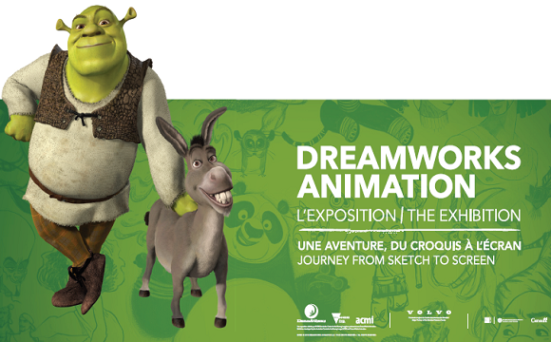

# DREAMWORKS ANIMATION: THE EXHIBITION

# Journey from Sketch to Screen

**About the Exhibition**

**DreamWorks Animation: The Exhibition - Journey from Sketch to Screen** provides a unique insight into the creative process behind the on-screen magic, as well as a rare glimpse into the studio’s collaborative, artistic and visionary approach to animation.

Celebrating more than 20 years of DreamWorks’ creative legacy—from its first feature film, ***Antz*** (1998), to ***How to Train Your Dragon 2*** (2014) and ***Trolls*** (2016)—the Exhibition charts the creative journey of a DreamWorks’ film.

Comprising rare and never-seen-before material, the Exhibition draws on DreamWorks’ archive of models, photographs, posters, maps, props, concept drawings, storyboards and original artwork. Featuring more than 400 exhibit items—alongside a range of highly immersive and interactive digital experiences—this represents one of the largest, most diverse exhibitions ever created to showcase the art of animation.

Created by ACMI in partnership with Universal Brand Development on behalf of DreamWorks, this unique exhibit offers a first-time exploration of the studio’s collaborative and visionary approach to animation, art, technology and storytelling. For the first time Melbourne-based curators and creatives have been brought together with the animators, artists and producers of an international studio. The Exhibition also presents the first ever in-depth exploration of DreamWorks’ ground breaking animated films—introducing visitors to the complex and creative animation process.

**DreamWorks Animation: The Exhibition** is structured around three key sections: Character, Story and World.

With a focus on DreamWorks’ distinctive approach to these core aspects of filmmaking, each section follows a film’s creative journey—from the initial idea to a fully realized animated masterpiece. The first section, Character, traces the evolution of iconic DreamWorks’ characters from original concept drawings and sketches to intricately developed personalities.

The middle section, Story, explores the process of constructing a feature-length narrative from original inspiration or idea to final storyline. The final section, World, focuses on the gorgeously detailed environments that are such an integral part of the DreamWorks films—placing characters into their settings and allowing worlds to unfold.